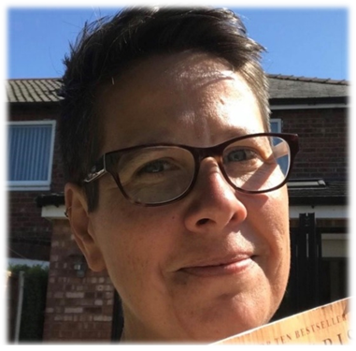
P
Case study
Name: Michelle Hebborn
Job title: Social Worker

What was your career journey prior to training to being a Social Worker and what did your early career look like?
I was not academic when I was at school, I struggled with reading and writing and I worked hard to pass my GCSEs. I attempted to do some A levels but I gave them up to do a BTEC National in Social Care as I knew I wanted a job where I could help people. I qualified with a distinction and applied to university to do a Social Work BA degree. I spent 4 years at University and graduated with Honours.
I first worked as an Older Person’s Social Worker, assessing people’s needs then setting up care packages for them. I now support people in their own homes who have a disability or are alcohol dependent, have dementia or issues with hoarding in their homes.
How did you become a Social Worker?
I started my BA Social Work degree when I was 19 years old. Prior to this I worked as a carer in an older people’s residential home. I have worked with a variety of different clients during my career; people who have mental health problems or physical disabilities, people with dementia and those who are dependent on alcohol and drugs.
My job is to assess the client’s needs so that I am able to draw up a plan of action and goals to meet the plan. Social work is about equality and has strong ethics and values. There are theories and models of social work which guide me on how best to help individuals. Social work is also about empowerment and doing “with clients” and not doing “to” or “for” clients.
What is a typical day for you?
I work in the community with adults. My week starts with new allocations then set up meetings with service users and their carers to access their needs. I spend a lot of the time in the office arranging homecare, day services, day care, and residential placements and put together reports to request funding for services needed for clients. I liaise with different members in the health sector to work together to support people. I also work with the Police on safeguarding cases and work with Age UK and food banks to support the most vulnerable in our community.
Do you have any words of encouragement for anyone thinking about a career in health and social care?
I have been a Social Worker for 21 years and I still love meeting different people. I get great satisfaction knowing I have contributed to someone improving their own quality of life. So if you care about people and want to make a difference to their lives then I would recommend Social Care for job satisfaction.

